Americanism/Patriotic Instructor
Promotion #5, February – March 2024
Department of California

1909 valentine Public Domain Chordboard
HAPPY VALENTINES DAY
To all my Auxiliary TRIBE brothers and sisters

Program Goals
Recognizing Star Families, Promoting Patriotism,
Flag Education, and Celebrating Patriotic Holidays

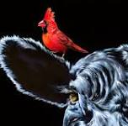
Madam Ambassador, Linda Roloff, Madam Department President, Diana Russell-Milton, Madame Past National President, Gwen Rankin, and all worthy and Honorable Line officers, appointed positions, PDP’s, District Presidents, and others, “Lend me your ears.” (Shakespeare, Jullius Ceasar) I come to praise thee and to impart information I feel important.

I was surfing the CA Department website and found information on reporting that I did not know existed. I want you to understand that I know many of you are light years ahead of me when it comes to this computer stuff and will say to yourselves “I knew that.” But I would also guess that some of you are in my class and would be amazed at the discovery. Especially if you are in a position where you might be able to use the information. I am. What I have discovered is that the Department of California has not been sitting on its hands when it comes to reporting on Americanism activities. As of February 10, 2024, The Department has donated 2,341 hours, driven 11,298, all done by 1,502 members. MANY KUDOS brothers and sisters. There are still a few auxiliaries that have not reported but I am sure The District Chairmen are working with them. We still have several months left to submit reports, so keep them coming.

Remember, California’s Presidential Primary Election is March 5, 2004. Please get out there and vote, it is probably the second most patriotic event one can do, the first being serving in the military.

Finally, I am including a copy of the awards requirements for Ambassador Linda Roloff’s Americanism program. I am sure this is unusual, but I want all to know exactly what she is looking for. Instructions and final entry date are in the article. I am probably just being lazy, for this I am sorry.

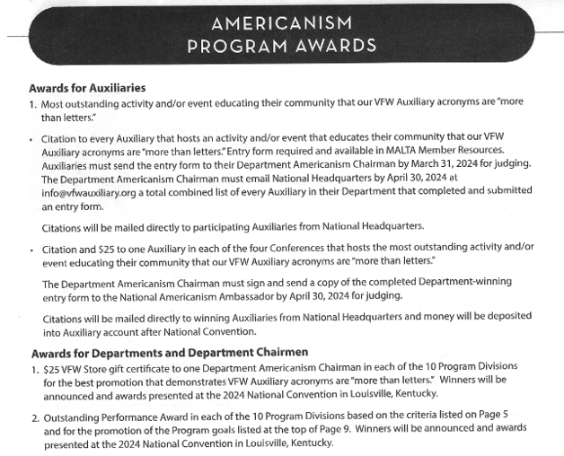
Department of California
Bill Niemeyer
Americanism Chairman/Patriotic Instructor
vfwauxbill@gmail.com

